1. Generate TLB, of the Plugin

Eg:

D:\ActiveX.NET\Source\ActiveX.NET\ActiveX.NET.Plugin\bin\Deb

ug>regasm ActiveX.NET.Plugin.dll /tlb:plugin.tlb

Note:

We only need to TLB for next steps, but the above command line registers the dll file as inproc server. We need to unregister the same in the next step.

1. Unregister the InProc Server using commandline

regasm /u ActiveX.NET.Plugin.dll

1. Run the solution with /regserver (To register OutofProc/EXE Server)

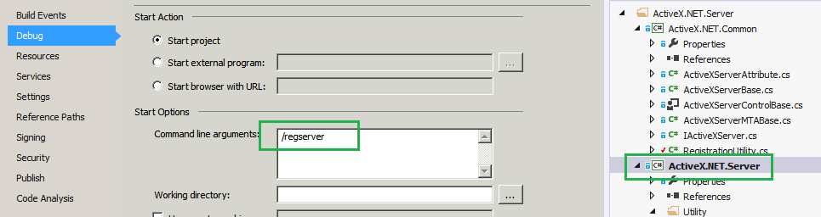

1. Open the sample excel file provided with the project
   1. Browse and add the generated TLB

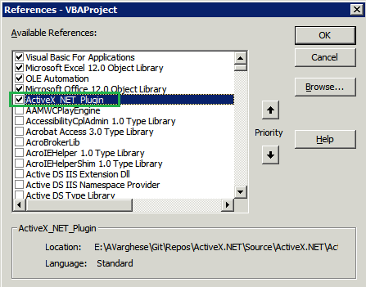

* 1. Add the following code to “Sheet1”

Private WithEvents plugin As ActiveX_NET_Plugin.SimpleObject

Private Sub plugin_FloatPropertyChanging(ByVal NewValue As Single, Cancel As Boolean)

MsgBox ("float proprety triggered")

End Sub

Private Sub Worksheet_Activate()

Set plugin = New ActiveX_NET_Plugin.SimpleObject

End Sub

Private Sub Worksheet_BeforeDoubleClick(ByVal Target As Range, Cancel As Boolean)

plugin.FloatProperty = 10

End Sub

Private Sub Worksheet_SelectionChange(ByVal Target As Range)

End Sub

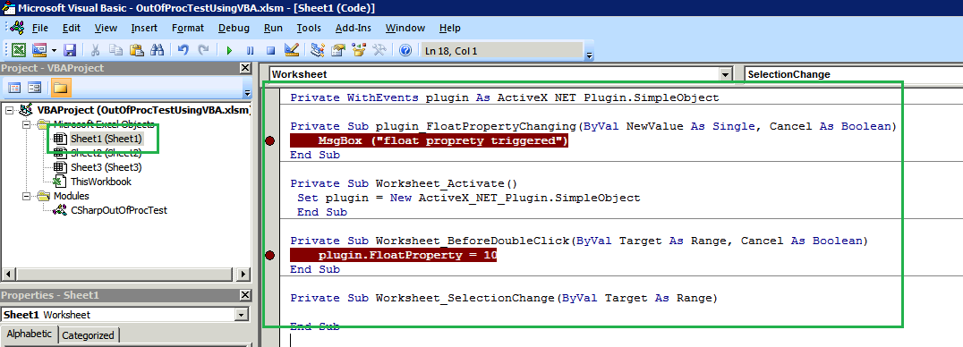

* 1. Click on Sheet1, and double click
  2. Event will be fired

